BlockChain Based Social Media without Bots and Gas Fee

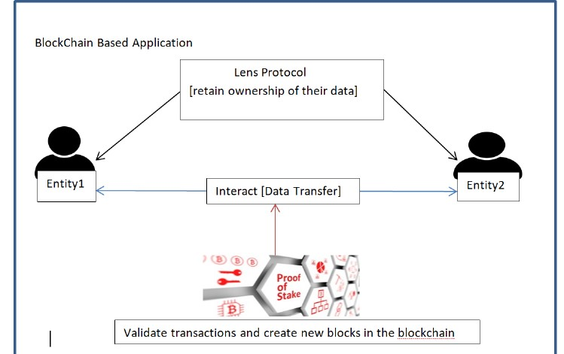

**PLANNING:**

The first step in the methodology would be to research and plan the project. This would involve identifying the key features of the GameGuides platform, understanding the requirements for integrating with Lens Protocol and other tools like Replicate and Tatum, and designing the user interface and experience for the platform.

* Development Environment Setup: The next step would be to set up the development environment for the project. This would involve installing and configuring the necessary software tools and libraries, setting up accounts on various blockchain platforms, and configuring the deployment environments.
* Smart Contract Development: The core functionality of the GameGuides platform would be implemented through the development of smart contracts using Solidity language. This would include the ERC1155 token contract for minting and selling tokens, as well as other smart contracts for various platform functionalities such as token gating and user authentication.
* User Interface Development: In parallel with the smart contract development, the user interface for the GameGuides platform would be designed and developed using Javascript and React. The user interface would need to be intuitive, user-friendly, and aesthetically pleasing, while also being fully integrated with the smart contracts and other backend tools.
* Integration with Lens Protocol and other tools: The GameGuides platform would need to be fully integrated with Lens Protocol to enable the token gating functionalities and other features. Additionally, tools like Replicate and Tatum would need to be integrated to enable text-based image generation and uploading of NFT metadata to IPFS.
* Testing and Deployment: Once the platform is fully developed and integrated, it would need to be rigorously tested to ensure that it functions as intended, is secure, and can handle a high volume of traffic. Once the testing phase is complete, the platform would be deployed to the Polygon Mumbai blockchain and made available to users.
* User Adoption and Feedback: The final step in the methodology would be to encourage user adoption of the GameGuides platform and gather feedback from users to inform future

improvements and updates to the platform. This would involve marketing and outreach efforts, as well as actively soliciting feedback from users through surveys, focus groups, and other means.

The implementation of GameGuides on the Polygon Mumbai blockchain using Lens Protocol and OpenZeppelin Defender Relayer has shown promising results in addressing the problems of vendor locking, data ownership, and fair revenue distribution in social media platforms.

The use of Polygon Mumbai blockchain has significantly lowered gas fees, making it feasible for users to interact with the GameGuides platform. The integration of Lens Protocol has enabled users to retain ownership of their data and mint their posts as ERC1155 tokens, which can be sold on any marketplace, providing a fair revenue distribution model for content creators. The token gating functionalities have also made it easier for producers to interact with consumers, enabling creators to monetize their loyal fan base exclusively.

Ledger Diagram:

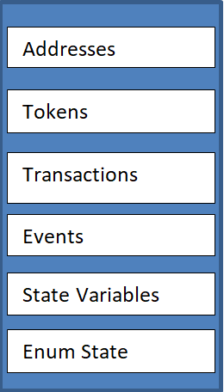

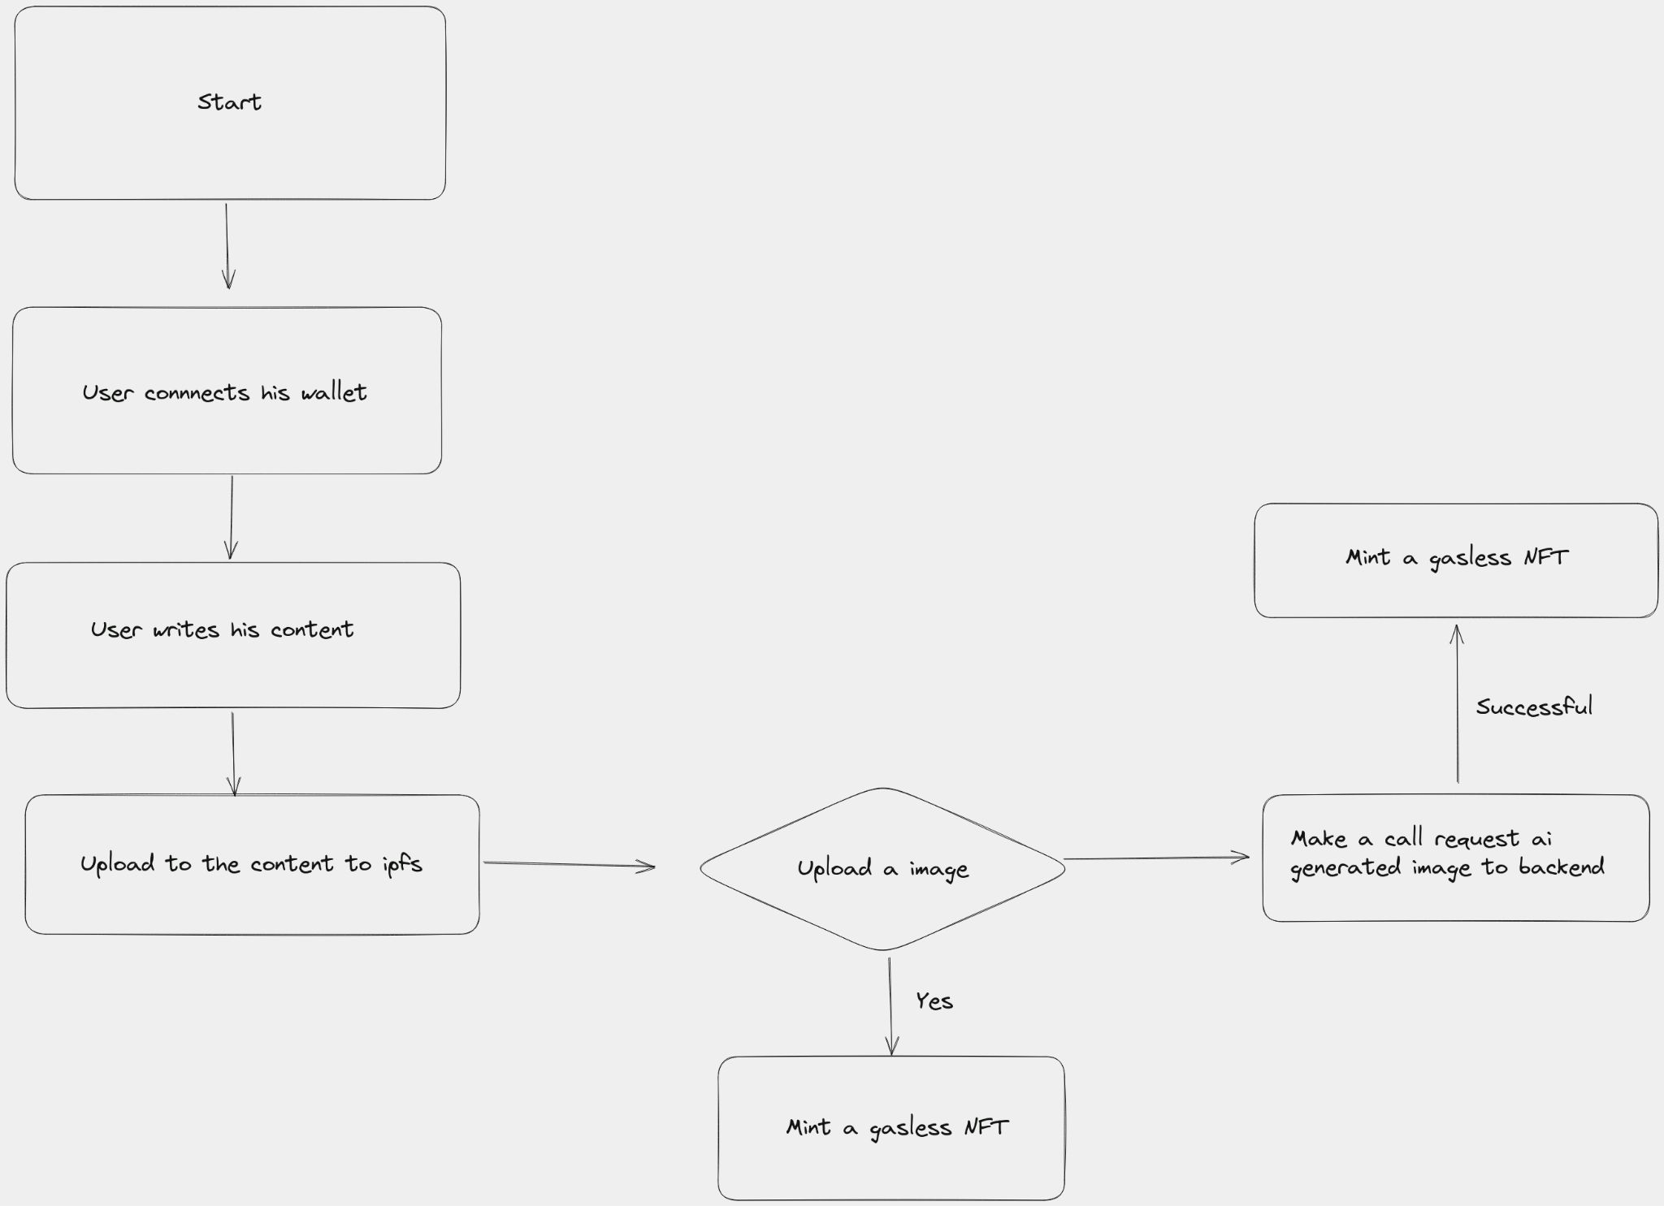Flow Diagram:

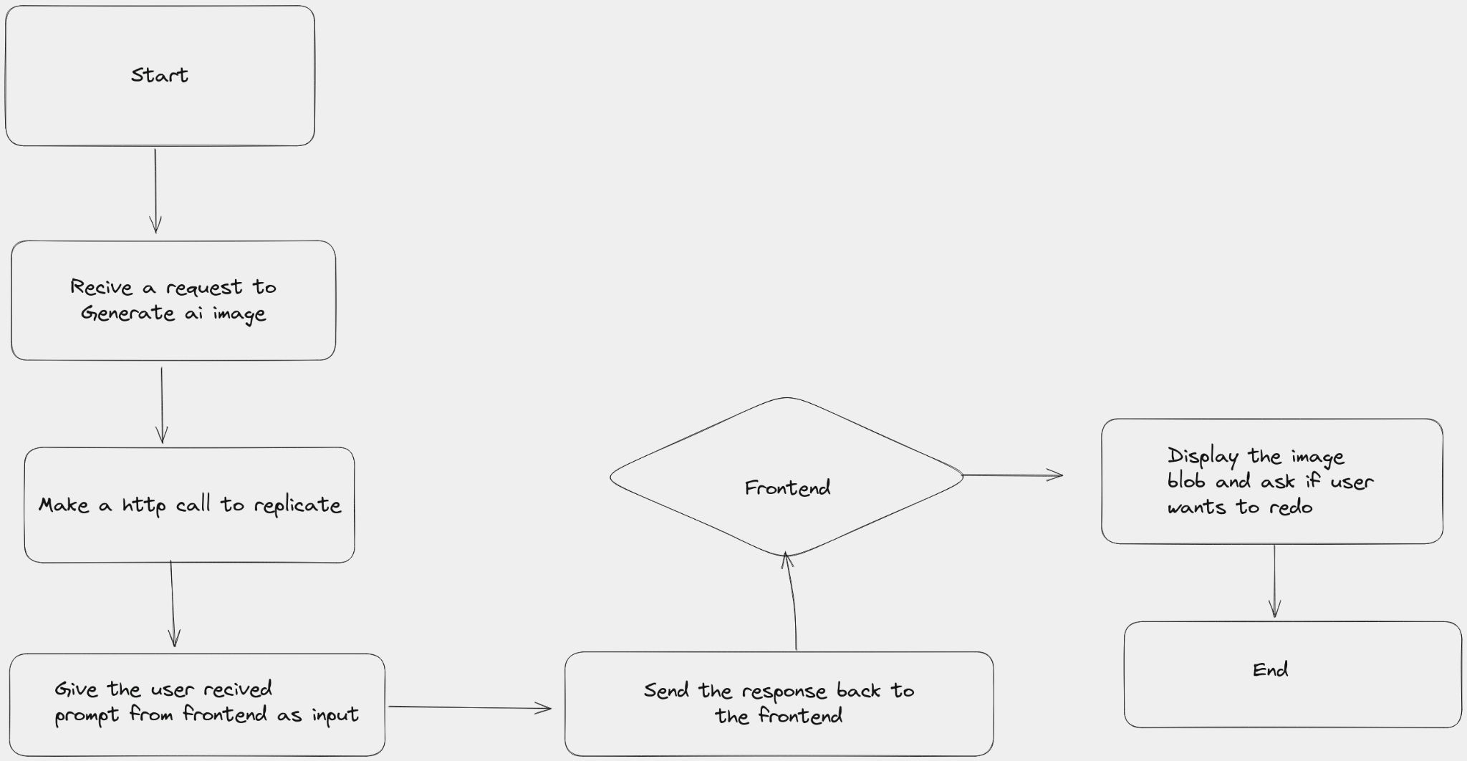

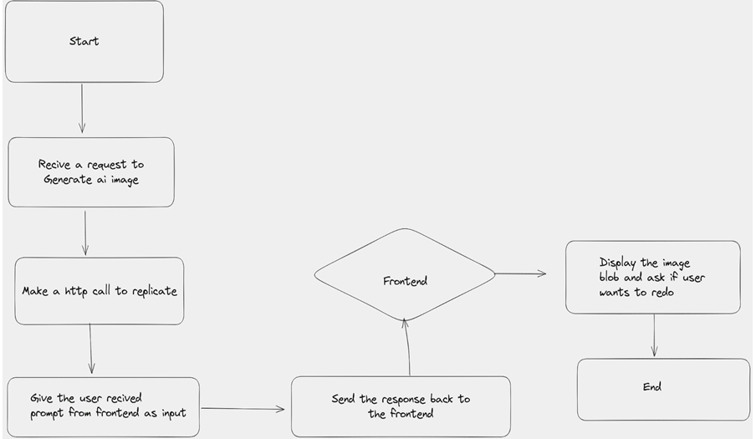

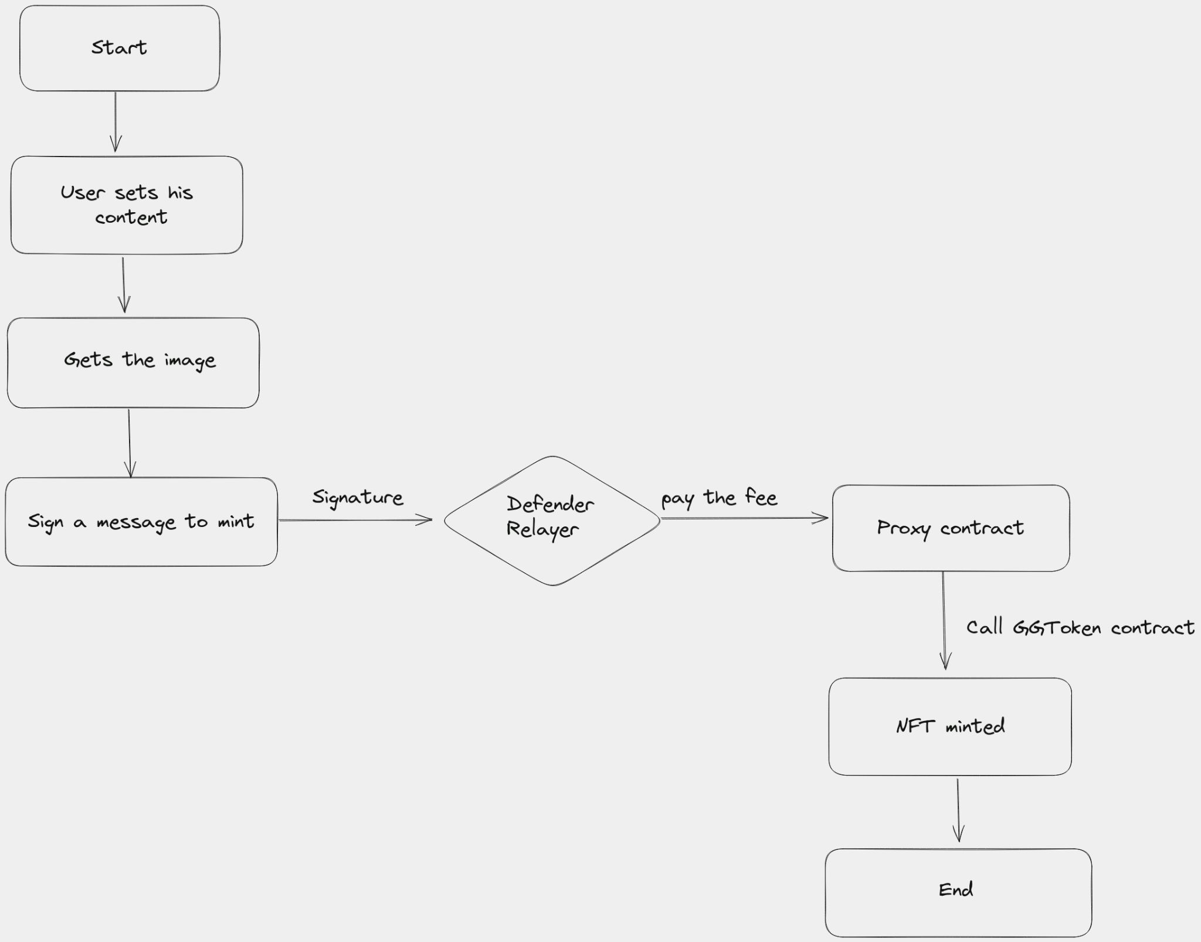

Sequence Diagram:

